**Experiment 8**

**Aim:** To understand cellular frequency reuse concept

**Theory:**

1. **Introduction to Cellular Network**

A cellular network is a radio network distributed over land through cells where each cell includes a fixed location transceiver known as base station. These cells together provide radio coverage over larger geographical areas.

User equipment (UE), such as mobile phones, is therefore able to communicate even if the equipment is moving through cells during transmission.

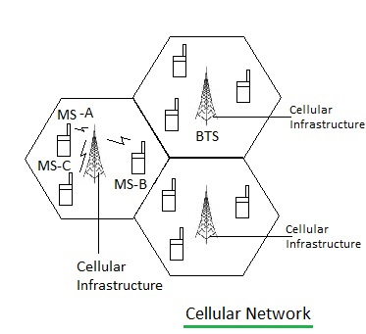

*Fig 1: Cellular Network*

Cellular networks give subscribers advanced features over alternative solutions, including increased capacity, small battery power usage, a larger geographical coverage area and reduced interference from other signals.

Cellular network technology supports a hierarchical structure formed by the base transceiver station (BTS), mobile switching center (MSC), location registers and public switched telephone network (PSTN).

1. **Cell formation**

The cell formation (CF) is one of the most important steps in the design of a cellular manufacturing system (CMS), which includes machines’ grouping in cells and part grouping as separate families, so that the costs are minimized. The various aspects of the problem should be considered in a CF. The machine reliability and the tool assigned to them are the most important problems which have to be modeled correctly. Another important aspect in CMS is material handling costs that they consist of inter-cell and intra-cell movement costs. Moreover, setup and tool replacement costs can be effective in CF decision making. It is obvious that CF cannot be completed without considering the number of demand.

1. **Frequency Reuse**

Frequency reusing is the concept of using the same radio frequencies within a given area, that are separated by considerable distance, with minimal interference, to establish communication.

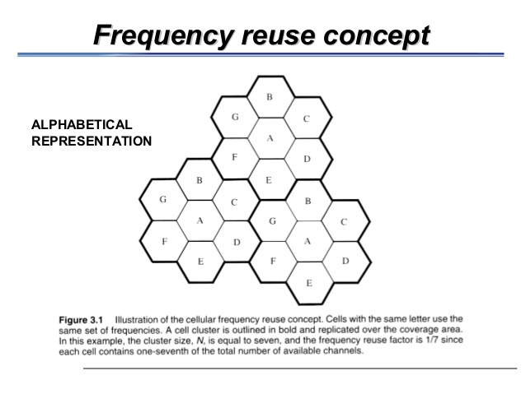

*Fig 2: Frequency Reuse*

Frequency reuse formula:

Assuming hexagonal shape cells of equal size

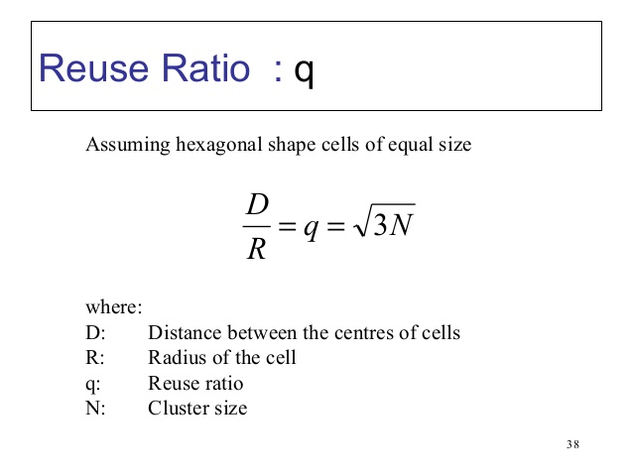

Where:

D: Distance between the centres of cells

R: Radius of the cell

q: Reuse ratio

N: Cluster size

Frequency reuse offers the following benefits −

* Allows communications within cell on a given frequency
* Limits escaping power to adjacent cells
* Allows re-use of frequencies in nearby cells
* Uses same frequency for multiple conversations
* 10 to 50 frequencies per cell

For example, when N cells are using the same number of frequencies and K be the total number of frequencies used in systems. Then each cell frequency is calculated by using the formulae K/N.

In Advanced Mobile Phone Services (AMPS) when K = 395 and N = 7, then frequencies per cell on an average will be 395/7 = 56. Here, cell frequency is 56.

1. **Co-channel cells**

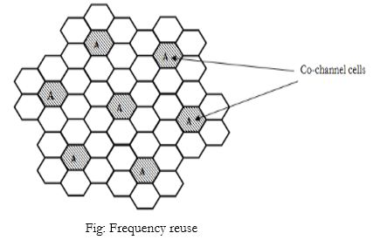

*Fig 3: Co-Channel Cells*

The same seven sets of frequency can be used after certain distance. The group of cells where the available frequency spectrum is totally consumed is called a cluster of cells.

Two cells having the same number in the adjacent cluster, use the same set of RF channels and hence are termed as “Co-channel cells

1. **Co- channel interference**

Co-channel interference occurs between two access points (APs) that are on the same frequency channel.

Co-channel interference or CCI is [crosstalk](https://en.wikipedia.org/wiki/Crosstalk_(electronics)) from two different [radio transmitters](https://en.wikipedia.org/wiki/Radio_transmitter) using the same [channel](https://en.wikipedia.org/wiki/Channel_(broadcasting)).

Co-channel interference can be caused by many factors from weather conditions to administrative and design issues.

Co-channel interference may be controlled by various [radio resource management](https://en.wikipedia.org/wiki/Radio_resource_management) schemes.

**Conclusion:** Thus in the above experiment, we performed a case study on cellular network and its various parameters such as cell formation, frequency reuse,co-channel cells and co-channel interference.